Sweet Treasure Studios is evaluating a change in their mobile game, Sweets Smash, to enhance player engagement. The goal is to compare the effectiveness of two transition methods: the current approach, Method A, where candy hitboxes gradually shrink, and a new approach, Method B, where the proportion of candies with enlarged hitboxes is reduced. The key question is whether Method B can increase weekly playtime, potentially leading to greater player retention and more in-game purchases. Our analysis investigates if Method B significantly increases playtime compared to Method A. A higher average weekly playtime could indicate greater engagement, supporting a switch to Method B to drive higher in-game purchases.

To confidently assess the effectiveness of Method B, we conducted a power analysis to determine the minimum number of players required in each group. Based on a desired power of 80% and a significance level of 5%, the analysis indicated that we needed at least 23 players per group to detect a meaningful difference in playtime increase between the two methods. This ensures that our findings are statistically reliable and that any observed effects are not due to chance. Playtime data were collected for players using both transition methods, measuring their playtime before and after the transition. The main variable analyzed was the PlayTimeDifference (the difference in weekly playtime before and after the transition). In this analysis, the Control group refers to players who experienced the current transition method, Method A, where the hitboxes around candies gradually shrink over a week, making the game progressively more challenging. The Treatment group includes players subjected to the proposed transition method, Method B, in which the proportion of candies with enlarged hitboxes is gradually reduced, rather than shrinking the hitboxes themselves.

The boxplot supports the idea that Method B generally yields a higher increase in playtime than Method A. The greater median and upper range for the Treatment group indicate that Method B is likely more effective in boosting player engagement. The clustering of red points in the scatter plot below at higher playtime levels after the transition phase also suggests that Method B is effective in maintaining or enhancing player engagement, reinforcing its potential as a preferred method for the transition.
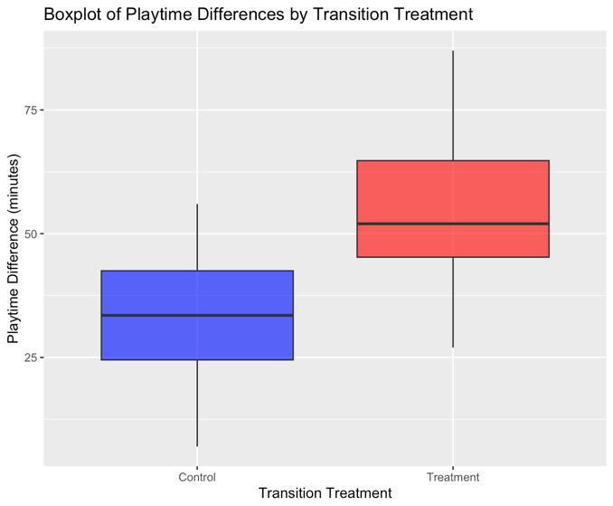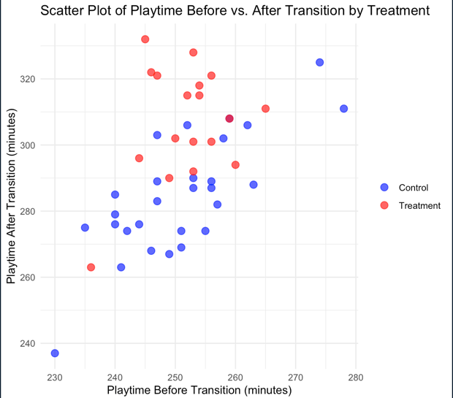
The increase in maximum, minimum, and mean playtime after the transition phase indicates that the transition strategies (Method A and B) positively impact player retention and engagement.
Statistic | Maximum | Mean | Minimum
Play Time Before | 278 | 251.26 | 230
Play Time After | 332 | 293.54 | 237

To systematically study the relationship between the transition method and playtime differences, we conducted a two-sample t-test comparing the average playtime increases between the Control group and the Treatment group. The test with full output is available in the appendix. The t-test revealed a significant difference in playtime increases between the two groups. Specifically, the Treatment group showed a higher mean increase in playtime (55.44 minutes) compared to the Control group (33.82 minutes), with a t-statistic of 5.1861, and a p-value of 2.601e-06. The 95% confidence interval for the difference in means indicates that this difference is greater than zero, providing strong evidence that Method B leads to a significantly larger increase in playtime than Method A. This statistically significant result suggests that Method B could be more effective in increasing player engagement, supporting Sweet Treasure Studios’ goal of enhancing in-game retention and potential monetization through longer play sessions.

However, additional factors, such as player skill level, game phase, or other in-game dynamics, may also influence playtime and should be considered in future studies. It is possible that further data collection and analysis of these factors could provide a more comprehensive understanding of what drives player engagement, allowing Sweet Treasure Studios to refine their transition strategy for even better retention outcomes.

Appendix
This Appendix contains additional figures and tables detailing additional data summarization information as well as additional model fitting output. All output provided is produced by R.
TransitionTreatment | Mean | SD | Median | IQR
Control | 33.8 | 12.0 | 33.5 | 18
Treatment | 55.4 | 16.2 | 52 | 19.5
There is a general trend of increased engagement post-transition. The descriptive statistics (mean, median, standard deviation) of the playtime differences for both Method A (Control) and Method B (Treatment) are shown below.
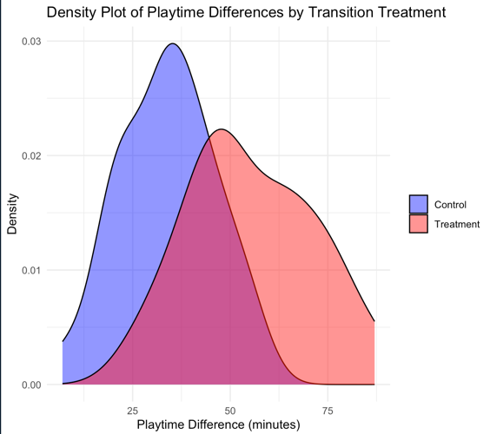
This density plot shows the distribution of playtime differences for both the Control group (Method A) and the Treatment group (Method B).
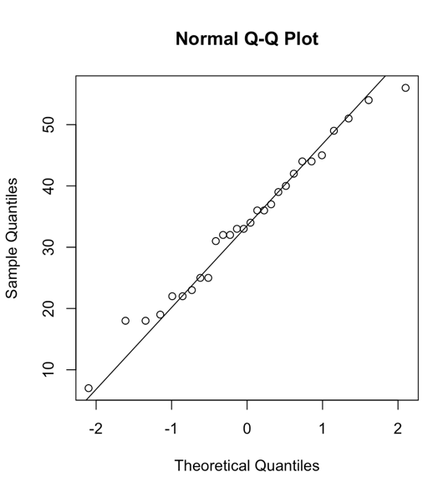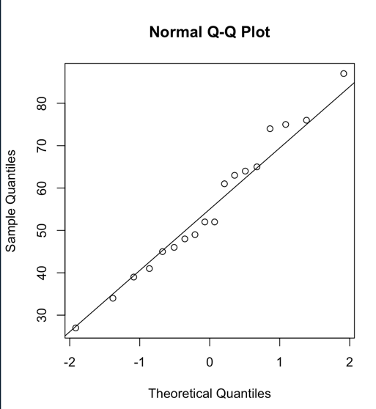
Before conducting the t-test to compare playtime increases between the Control (Method A) and Treatment (Method B) groups, we checked several key assumptions given our sample size of fewer than 30 players per group. The Q-Q plots showed that the data points closely aligned with the theoretical line, suggesting that the playtime differences in each group approximately followed a normal distribution, which supports the validity of the t-test. Independence was ensured, as the data for each group was collected from different players without overlap, satisfying the assumption that observations within and between groups were independent. Additionally, due to the small sample size and potential for unequal variances between groups, we used Welch’s t-test.
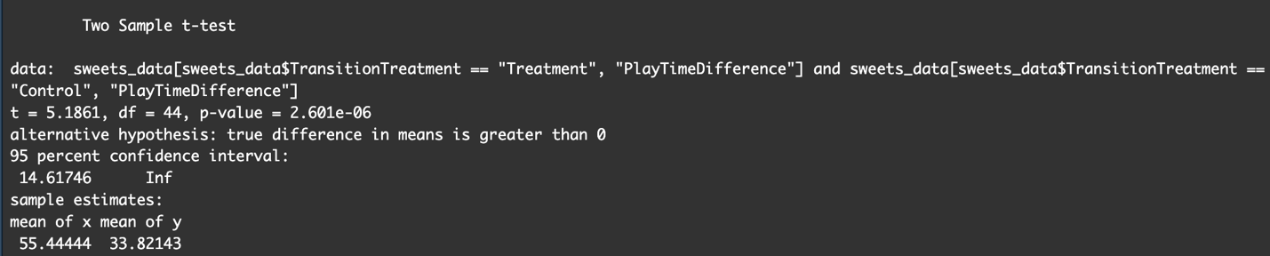
The figure above presents the results of the two-sample t-test. With a null hypothesis that there is no difference in the mean playtime increase between the Control group and the Treatment group, the test rejects the null hypothesis, indicating that Method B significantly increases playtime more than Method A. The 95% confidence interval suggests that the true difference in means is greater than zero, supporting the conclusion that Method B is likely more effective at enhancing player engagement. When paired with the observed differences in mean playtime increase, this result strongly supports adopting Method B to drive longer player sessions.

